LOANENDS PRIMARY SCHOOL

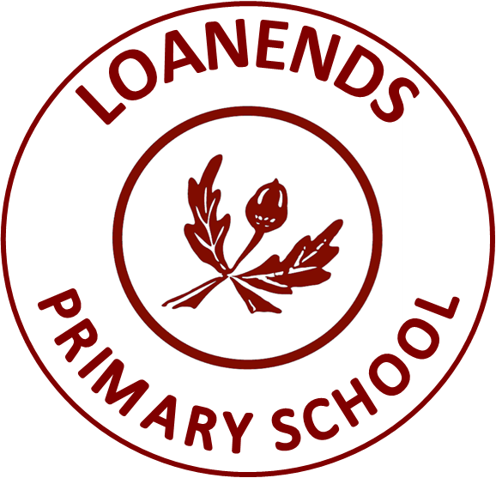

Personal Development and Mutual Understanding Policy
Date of Rewrite  of Policy | September 2020 | PRINCIPAL  Mrs L Armour
Date of Governor  Ratification of Policy | 29.09.20 | CHAIR OF BoG  Mr R McCourt
Review Date  of Policy | September 2023
Person (s) Responsible for review and update of Policy

September 2020

PERSONAL DEVELOPMENT AND MUTUAL UNDERSTANDING POLICY

Mission Statement:

“We actively strive to provide a caring and safe learning environment, where every child matters and is respected. Our passion is to nurture and empower our pupils to achieve their true potential, with the support of a highly dedicated and professional staff team.”

Context:
The school believes in the holistic development of the child to his or her full potential. It will provide a broad, balanced and differentiated curriculum. Loanends is committed to having high expectations for academic achievement, behaviour and conduct. As a school we believe that UNCRC Article 29 of the United Nations Convention on the Rights of the Child (CRC) underlines our school vision.
“Education must develop every child’s personality, talents and abilities to the full. It must encourage the child’s respect for human rights, as well as respect for their parents, their own and other cultures and the environment.” (goals of education, Article 29).
Our school will seek to promote attitudes and values linked to other school policies but with particular reference to the Positive Behaviour, SEN and Anti-Bullying Policies. The school will endeavour to foster personal integrity among staff, pupils and in aspects of the life of the school.
Loanends regards parents as valued and respected educational partners who are made to feel welcome at the school. As a pastorally driven school, Staff will provide regular feedback to parents on the progress of pupils and offer to them any other relevant pastoral guidance and support. The school places considerable importance and value upon its links with the local community and the contribution made by outside agencies.

Rationale:
The Northern Ireland Curriculum seeks to give greater emphasis to Personal Development and Mutual Understanding (PDMU) which it considers to be an important element within the curriculum. PDMU is therefore one of six main areas of learning within the Northern Ireland Curriculum focusing on emotional development, social skills, learning to learn, health, relationships and sexuality education and mutual understanding in the local and global community.
PDMU supports the Northern Ireland’s Curriculum’s Aim:
‘To empower young people to achieve their potential and to make informed and responsible choices and decisions throughout their lives.’
In addition, the PDMU Curriculum also supports the Northern Ireland Curriculum’s objectives:
- to help young people develop as “individuals” by:
- developing self-confidence, self-esteem and self-discipline;
- understanding their own and others’ feelings and emotions;
- developing the ability to talk about how they feel;
- developing their motivation to learn and their individual creative potential;
- listening to and interacting positively with others;
- exploring and understanding how others live.

- to help young people to develop as “Contributors to Society” by:
- becoming aware of some of their rights and responsibilities and some of the issues and problems in society;
- contributing to creating a better world for those around them;
- developing an awareness and respect for the different lifestyles of others;
- reflecting on similarities and differences in families and people and
- understanding some of their own and others’ cultural traditions.
PDMU does not begin or end with school but will continue to feed into society and the life of each child and their family. It will continue to evolve as a child’s journey continues through their school years and into adulthood. We see it as our responsibility to provide them with adequate teaching and empathetic responses to “caught” activities in order to equip them for post-primary and then into adulthood.
“Education is not just about learning and cognitive skills. It is also about helping children to learn about themselves, to be able to live peaceably with themselves and with others and to help them to develop into competent, mature, self-motivated adults.”
Denis Lawrence,” Enhancing Self-Esteem in the Classroom. (2006)

Policy Statement:
In Loanends Primary School, we believe that the development and implementation of this Policy will complement our ethos, values and mission statement. We feel that PDMU, is the hidden core of the curriculum and we fully understand that planning for PDMU will take into account our school ethos and the good practice which already exists and often is commented upon by visitors. We are also mindful of the fundamental importance of TRUST between children and staff members, even a trust relationship with only one school adult. Children work harder and together with people who care about them and they trust. (NIC).
As noted earlier, PDMU concentrates on developing each child, giving them knowledge, developing their attitudes, their awareness of life skills, fostering good relationships, knowing about appropriate behaviours in and out of school, broadening their thinking skills and personal capabilities, making each child emotionally aware, engraining values and promoting life skills to take them into their future as adults.
Therefore, in implementing this Policy, Loanends Primary School, (in line with NIC guidance), will seek to foster an environment in which pupils are:
- treated fairly;
- safe both physically and emotionally;
- close to others and
- part of the school.
Each member of staff will have a role to play in developing and nurturing positive relationships with pupils. This will be demonstrated by:
- actively listening to pupils;
- validating their feelings;
- demonstrating kindness and
- showing compassion and respect.

Why teach PDMU?
PDMU is one of the six areas of learning in the primary curriculum. It is divided into two main strands and teachers use these strands to deliver the nine statutory Statements of Minimum Requirement. The latter are divided into themes.

 | Strands | Nine Themes
Strand 1 | Personal Understanding and Health  Focuses on personal and emotional issues as well as health, wellbeing and safety matters. | - Self-awareness  - Feelings and Emotions  - Learning to Learn  - Health and Safety
Strand 2 | Mutual Understanding in the Local and Wider Community  Examines issues relating to personal and social relationships, interdependence and the need for mutual understanding and respect in the community and wider world. | - Relationships  - Rules, rights and responsibilities  - Managing conflict  - Similarities and differences  - Learning to live as Members of the Community

Benefits for the School and Local Community:
PDMU has many benefits for the school, the local community as it helps pupils:
- Develop a sense of personal and social responsibility;
- Show a concern and empathy for others;
- Demonstrate positive and healthy behaviour, including drug and alcohol awareness;
- Have integrity and moral courage;
- Show respect;
- Know they have a voice and will be listened to;
- Develop collaborative, constructive working relationships and
- Feel valued which will lead to a more productive learning environment for all.

Benefits for Pupils:
All pupils, through the teaching of the PDMU Curriculum will be encouraged to:
- Develop self-confidence and self-esteem;
- Manage their emotions and attitudes;
- Foster social skills, empowering pupils to deal with situations appropriately;
- Develop moral thinking and good decision-making skills;
- Cultivate an understanding of the importance of healthy lifestyles;
- Skills for keeping safety and avoiding danger;
- Recognise their learning preferences;
- Have respect for other cultures and beliefs;
- Develop an awareness of interpersonal skills, working collaboratively with others;
- Develop an awareness of how they will have an active role in the future of society.

Aims of Personal Development and Mutual Understanding:
In the knowledge that PDMU is a statutory part of the curriculum, we must be mindful that it will permeate the whole curriculum and school ethos. Therefore, it is imperative that the implementation of this Policy and the teaching of the nine statutory minimum requirements will have a positive impact on teaching and learning within our school.
Though PDMU we intend to:
- Deliver PDMU through the two interconnected strands and teach and explore all nine statutory statements of minimum requirement, from Foundation Stage to Primary 7.
- Integrate the “Living Learning Together Programme” and other resources referenced in the Key Stage Progression Grids (NIC), to help support the teaching and learning of PDMU.
- Help the pupils to learn about themselves, their place in society, how they learn and how they deserve to be respected and valued.
- To develop children’s self-esteem, self-confidence and self-worth.
- Give the children the tools to help them manage their feelings and emotions.
- Encourage our pupils to be motivated and ambitious young people with a desire to succeed, no matter the task.
- Develop the three main curriculum skills, namely: Cross Curricular Skills, Personal Capabilities and Thinking Skills.
- Ensure that all children are aware of the dangers in our society e.g. drugs, alcohol, bullying, abuse etc and know who to go for help.
- Promote good relationships with family, friends and future colleagues.
- Promote working as an individual, in pairs and in groups, to encourage the pupils to develop their own ability to express themselves in a variety of different ways.
- Encourage children to follow a healthy lifestyle and to keep safe.
- Understand why rules are needed, how to act responsibly and how to deal with conflict effectively.
- Develop an awareness of peoples’ similarities and differences, being respectful of others’ beliefs and cultures and be aware of the diversity in our society.
- Encourage pupils to become moral and just citizens, taking responsibility for their own actions and enable them to appreciate how their actions can impact upon society.
- Enable our young people to be more tolerant and patient of others.

Who Should Be Involved?
Role of Governors | - To be aware of statutory requirements.  - To ensure that the school has a PDMU Policy reflecting DE Policy.  - To support the Principal in ensuring the implementation of the policy.  - To ensure that the school ethos reflects the principles of PDMU.  - To ensure PDMU is incorporated into the cycle of School Development Planning.
Role of Principal | - The Principal will actively promote the development of PDMU within the school.  - The Principal will decide how the subject is to be implemented in consultation with all staff.  - The Principal will encourage the training of all staff where required.  - The Principal will support and consult with the Coordinator and feedback to the Board of Governors.  - The Principal, alongside the Coordinator will review the progression of the subject.
Role of Coordinator | - Liaise with the Principal and all staff in the development and regular review of the PDMU Policy.  - Oversee and support staff as they plan for the inclusion and teaching of the nine PDMU themes.  - Compile and document a resource list.  - Liaise with Pastoral Care Coordinator to ensure RSE and PDMU Policies are linked.  - Monitor Medium Term plans and feedback to staff in a timely manner.
All staff will be encouraged to promote PDMU throughout all aspects of daily life within the school. This area of the Curriculum will be Coordinated by Mrs Campbell, with some initial support from the Principal. This area of the curriculum will be developed through action planning, refining and refreshing of planners, PRSD visits, wall displays, feedback from pupils, and homework activities. Teachers’ planners will be submitted to the Coordinator for reviewing on a bi-monthly basis together with evaluated plans from the previous cycle. Changes will be made accordingly, and schemes of work updated to reflect the monitoring outcomes.

Methods of Delivery:
Personal Development and Mutual Understanding will be delivered as an individual subject area with time set aside on each class’s weekly timetable.
It will also be developed through all other areas of the Curriculum, as it will support our school’s ethos, and will help support all aspects of teaching and learning.
Teachers will deliver PDMU by using some of the nine themes throughout the school year and will ensure that appropriate breadth of content is covered within the Key Stage. The nine themes need not necessarily be taught in one year. The core of the work will be covered using the Living Learning Together Programme and supplemented by other resources identified within the NIC Progression Grids.
The nine key themes listed above will be revisited in each Key Stage, thereby developing and progressing pupils’ skills and knowledge as they move through the school. Teachers, as in all other subject areas, will use a blended approach of teaching styles, including individual, paired and small group work. Effective links with other curricular areas will be made and will be explored through class discussion, topic work, circle time, cooperative games and the use of technology. It is incumbent upon all teachers create a learning environment built on trust which in turn will lead to a positive and productive learning climate for our pupils.

Learning Approaches and Methodologies:
The NI Curriculum notes that the approaches and methodologies used in PDMU are crucial to its effectiveness. As PDMU is largely concerned with the development of values and attitudes, it is extremely important that children have an opportunity to develop these naturally as a consequence of their investigations and guided critical reflection on issues. The NIC therefore recommends the following:
- Active and participatory learning methods: pupils will experience learning for themselves, they will have an interest and increased understanding of their learning and the importance of learning.
The role of the teacher has evolved whereby the teacher is the Facilitator who will guide and direct the learning of each child in their care.
- Issue-based approaches: pupils will explore a greater understanding of the complex nature of certain issues, which are relevant, local, global and current in the lives of the pupils.
- Exploring pupils’ and society’s attitudes and beliefs: pupils will begin to take responsibility for their own values and actions, having an awareness of what is right and wrong and be aware of Human Rights and how this can impact on the school, local and global communities.
- Managing Conflict: pupils will learn to manage their own emotions and those of others’ and to show understanding and sensitivity towards controversial or sensitive issues.

Active and Participatory:
It is accepted that active and participatory learning approaches are the most effective method of delivery for PDMU. By encouraging pupils at our school to investigate issues for themselves, to suggest solutions and to make decisions based on what they have learned, this will significantly foster self-confidence, self-discipline and self-control. When children are given the opportunity to become actively involved in their learning at different levels, they:
- Are placed at the heart of the learning process;
- Learn more when they can make sense of what they are learning;
- Become active and generate high levels of interaction and stimulating discussion;
- Experience and discover learning for themselves;
- Learn to work collaboratively;
- Construct new meanings and acquire understanding;
- Take increasing responsibility for their learning;
- Become more critical and discerning and
- Are able to transfer learning to different situations.
A wide variety of active learning methods will be used by teachers to support PDMU lessons throughout the course of the school year:

Learning Aim | Methodology
Generate a number of ideas quickly. | - Brainstorm
Consider a specific situation. | - Role play  - Visitor Technique
Learn to negotiate, listen to and support each other. | - Drama
Promote cooperation. | - Co-operative games
Question information presented. | - Use photographs/pictures as a stimulus  - Use media television advertisements
Gather own thoughts and take a viewpoint. | - Open-ended statements
Express own opinions, promote critical thinking, and respect the views of others. | - ‘Agree or disagree’ continuums
Promote communication and critical thinking. | - Circle time  - Twos to Fours  - Storytelling
Represent ideas or concepts. | - Collage work
Explore issues of bias and stereotyping. | - Freeze Frames
Gather information, record findings and interpret data. | - Hot Seating  - Questionnaires and surveys

Enquiry-Based:
Enquiry-based learning approaches allow children to develop a greater understanding of the complexity of certain issues, to express their own and others’ opinions, and to make choices about their own learning.
- pupils will explore a greater understanding of the complex nature of certain issues, which are relevant, local, global and current in the lives of the pupils.

Values-Based:
PDMU encourages pupils to take responsibility for their own values and actions, having an awareness of what is right and wrong and be aware of Human Rights and the UNCRC Rights of the Child and how this can impact on the school, local and global communities. By using this approach, it encourages children to:
- Explore the impact of Human Rights principles on their own lives and
- Examine the impact of Human Rights on the classroom community, through for example the negotiation of a Class Charter.

Emotional Dimension:
From time to time, Personal Development and Mutual Understanding issues may result in conflict. All conflicts have both rational and emotional dimensions. It is important therefore that we allow children to have scope to explore ways to manage conflict, manage their own emotions and show sensitivity to the emotions of others. This emotional dimension has important consequences for teaching and learning approaches, especially when exploring controversial or sensitive issues.

Other Curricular Links:
PDMU has strong links with the other five areas of learning and can be explored through a range of topics and learning methods:
The Arts:
Help children to explore ways of expressing themselves through drama, music, art and design.
Language and Literacy:
Help children to develop vocabulary to discuss emotions and feelings through talking and listening, reading, independent writing, drama and role play situations.
Mathematics and Numeracy:
Use statistics to inform children and for gathering of information they have gathered in surveys and questionnaires.
Physical Education:
Help children to develop self-esteem, confidence, be aware of health and exercise.
Develop working as a group or team, to develop their awareness of fairness and treating others with respect.
The World around Us:
Help children to understand other cultures and other places and times. Develop their awareness of their own talents, thoughts and feelings.

Staff Development:
As school it is always our aim to keep our knowledge up to date and ensure as far as possible our approaches are fresh and relevant to the needs of our pupils and society in general. Should courses become available, staff may be given the opportunity to avail of training. They will also be encouraged to develop their skills through personal research and dissemination of good practice from colleagues in other schools. It will also be included as part of the statutory PRSD process so that all staff are appraised in its delivery and so that any potential training needs, help or support can be provided by the Coordinator. Baker Days, Curriculum Development Afternoons and School Development Days will be set aside for this purpose.

Monitoring and Assessment:
- The Coordinator, and on occasion with the support of the Principal will monitor planners and assess the effectiveness of the teaching of PDMU across the school.
- An Action Plan will be collated at a Staff Development Day to further enhance our work in this area.
- The Coordinator will maintain a file of evidence on a yearly basis and ensure that there is full coverage of the curriculum by completing the monitoring grid.
Assessment of Personal Development and Mutual Understanding is as important as any of the Areas of Learning. It must be remembered that personal rates of development are not and cannot be standardised. With this in mind, assessment and reporting should take account of and reflect each child’s current strengths and developmental needs. For some children, moving on from an early stage of Personal Development and Mutual Understanding may not be possible. Assessment therefore will focus on:
- Knowledge and understanding and
- The child’s ability to demonstrate the skills that are being learned and practised.

Self-Assessment:
This is a skill that needs to be learned and practised. It is therefore our responsibility to encourage children to recognise the processes of their own learning. These include:
- Reviewing progress;
- Setting targets;
- Negotiating their own pathways and
- Recording their achievements.
Encouraging children to talk about and reflect on activities and situations in which they have been involved will also help them to learn to use their judgement when considering:
- What have I done?
- What were the consequences?
- How did I feel about it?
- What might I do differently in the future?
- What did I find easy/ difficult/enjoyable etc.
- How might I achieve changes the next time?
Children should be given the opportunities to record their feelings or what they have learnt.

Equal Opportunities:
As teachers we must give children the opportunities to work with a wide range of people: the opposite sex, different race or culture or pupils in a different ability level. Working in a variety of situations will develop the children’s tolerance, respect and understanding of others. All children have the right to learn and develop as individuals at school, as a staff we strive to make our pupil’s confident and responsible young people of the future.

Review:
This Policy will be reviewed every three years or sooner in light of new legislation or recommendations from the Department of Education.

Related School Policies:
Attendance Policy | Health and Safety
Pastoral Care | Relationships and Sexuality Education
Safe Handling | Intimate Care
First Aid | E-Safety
Educational Visits | Staff Code of Conduct
Drugs Policy  SEN Policy | Teaching and Learning Policy  Positive Behaviour Policy  Anti-Bullying Policy

Appendix 1: Statements of Minimum Requirement
THEME 1: SELF AWARENESS
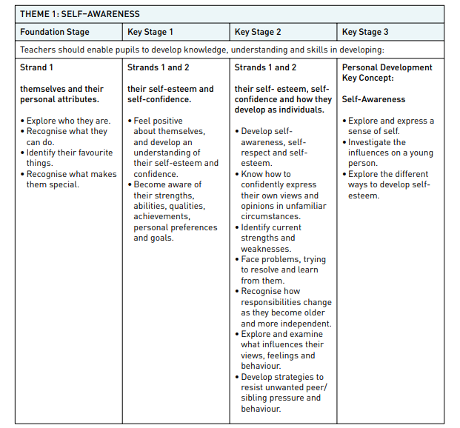
Appendix 1

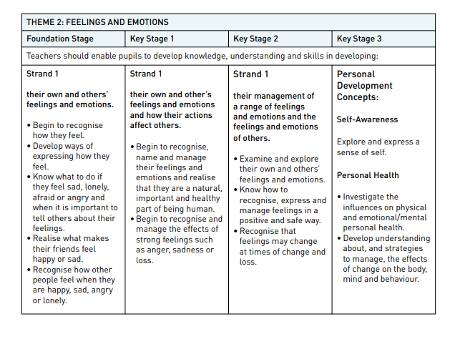
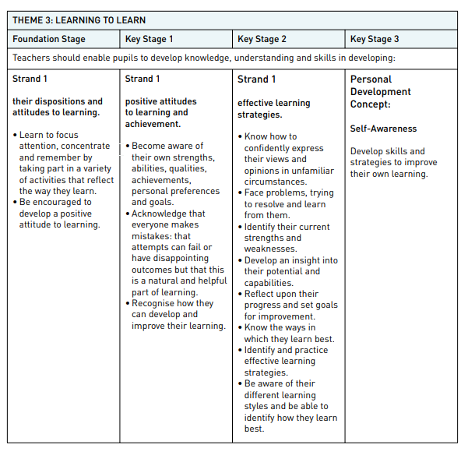
THEME 3: LEARNING TO LEARN

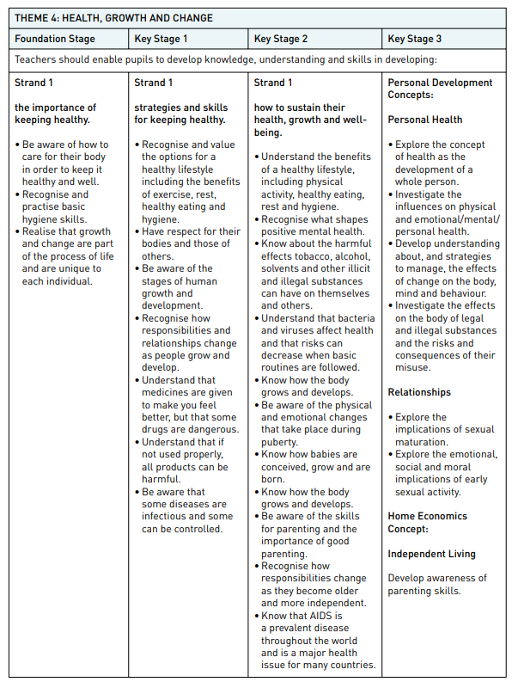
THEME 4: HEALTH, GROWTH AND CHANGE

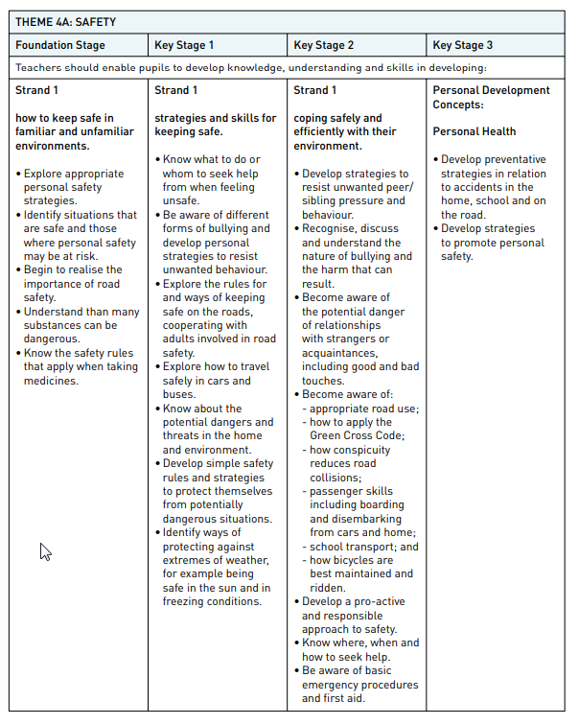
THEME 4A: SAFETY

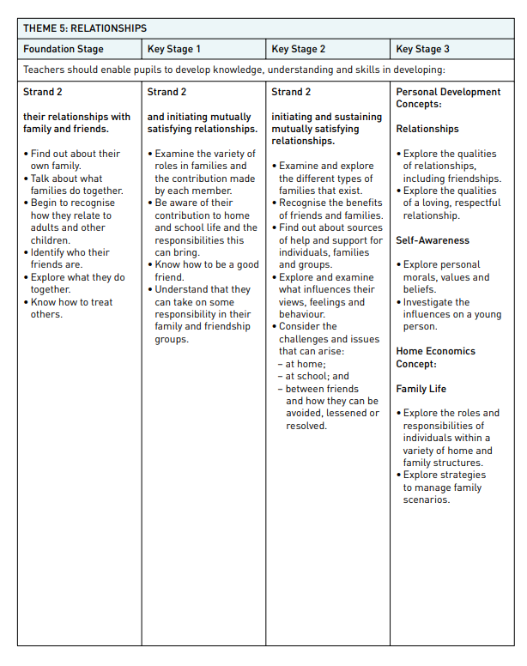
THEME 5: RELATIONSHIPS

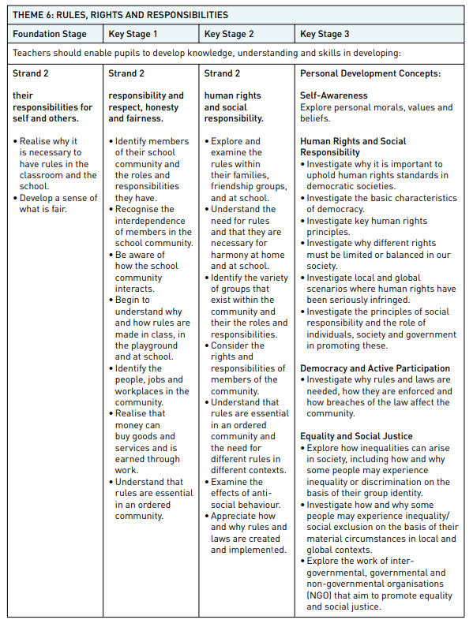
THEME 6: RULES, RIGHTS AND RESPONSIBILITIES

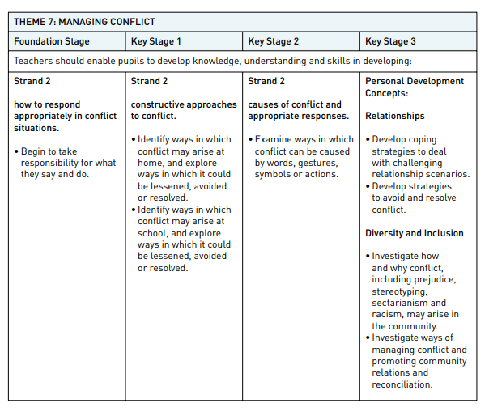
THEME 7: MANAGING CONFLICT

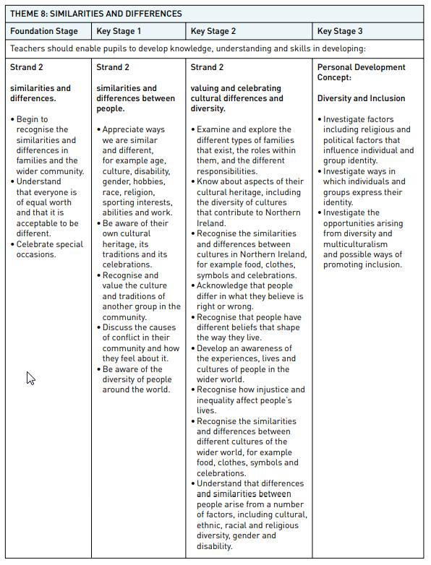
THEME 8: SIMILARITIES AND DIFFERENCES

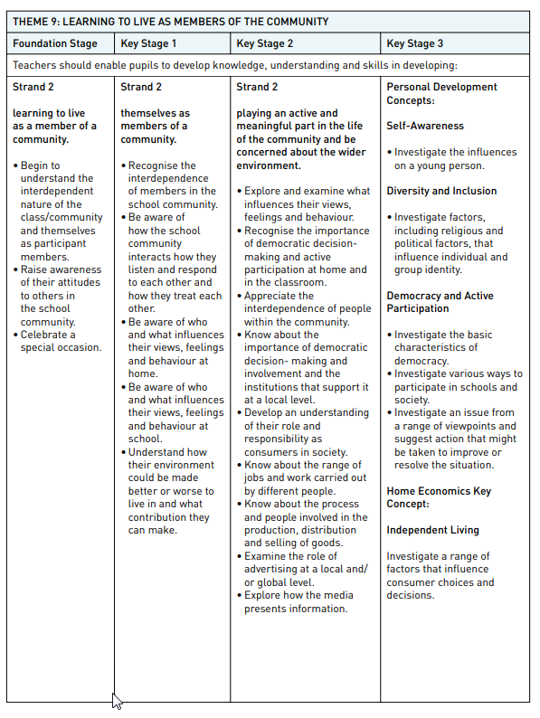
THEME 9: LEARNING TO LIVE AS MEMBERS OF THE COMMUNITY

Appendix 2

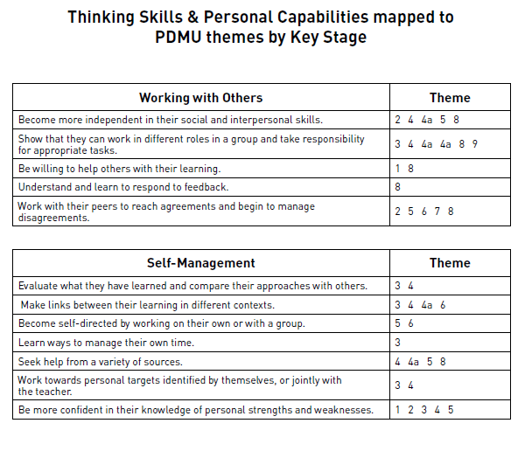
Foundation Stage

Key Stage 1
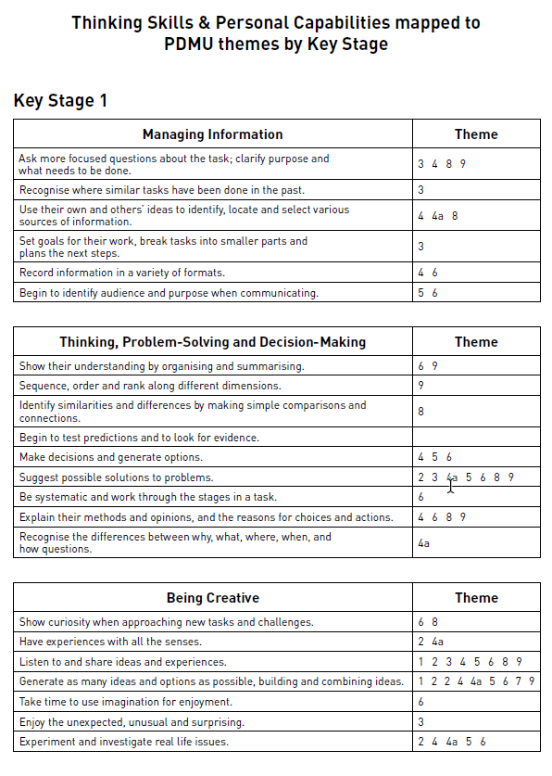

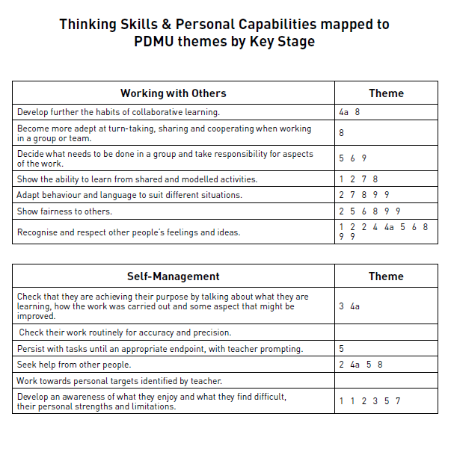

Key Stage 2
